## Vi Editor - Assignments

1. Invoke the vi editor with a filename (which is to be created)

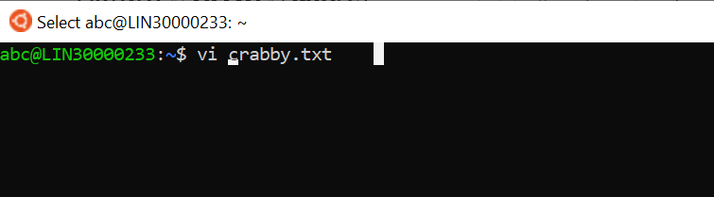

1. Type a few lines(at least 10) in the editor. Let one or more lines contain the words given below.

Delhi Mumbai Chennai Mumbai

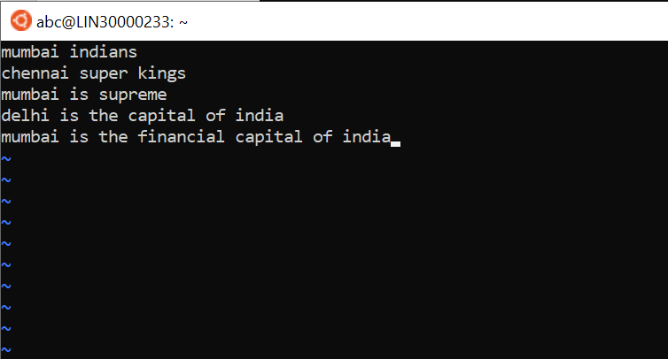

1. Save the file without exiting the editor

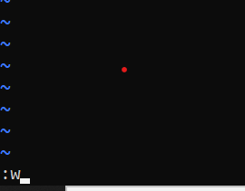

1. Navigate quickly to the beginning & end of the file

Ans: Navigate quickly to the beginning & end of the file

1. Delete first two lines & copy it after the last line.

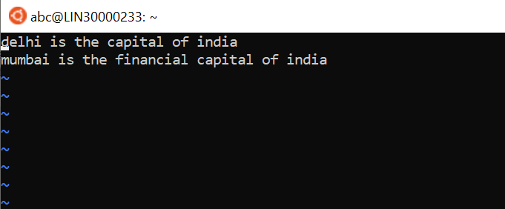

1. Now Copy the last two lines & paste them before the first line.

Ans: 2yy and then **p**

1. Combine last two lines of the file in a single line.

Ans- J

1. How will you insert a line before the first line? (Hint : Find such an option in the tutorial document)

Ans- go to first line

Hit replace mode

Hit **shift + enter**

**Use insert mode to edit**

1. How will you paste a yanked buffer before the current line?

Ans- using **P**

1. Search the document for a string “Delhi”

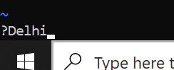

1. Replace a single occurrence of “Delhi” with “Mumbai”

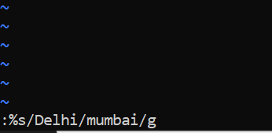

1. Replace all occurrences of “Delhi” on a particular line with “Mumbai” using one command

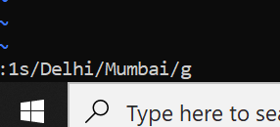

1. Replace “delhi” with “Mumbai” for the entire document using one command.

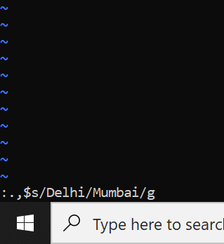

1. Replace all occurrences of “Delhi” with “Mumbai” for part of a document (e.g. line number 13 to 37).

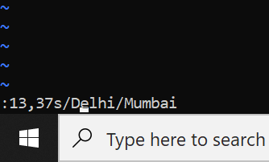

1. Undo the above command
2. Replace only the first occurrence of “delhi” with “mumbai” in each line, for part of a document (e.g. line number 13 to 37).

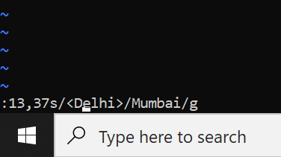

1. Undo the above comment. Redo it. Undo it again.

Ans:-:u

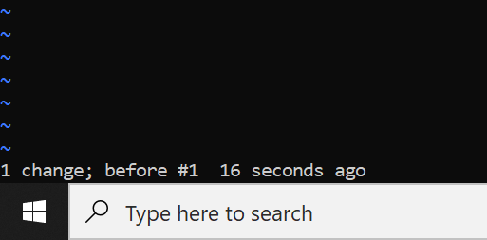

1. Replace all occurrences of “Delhi” with “Mumbai” for complete file interactively.

Ans:.,$s/delhi\|Delhi/Mumbai/g

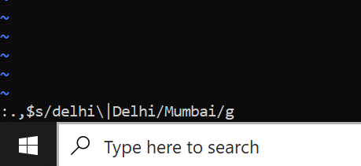

1. Search for a word backwards. Loop through all matches.

Ans:-?Delhi

1. Search for a word forwards. Loop through all matches

Ans-/Delhi

1. Join two lines together.

Ans-take the cursor anywhere on the last line and click J to join the two lines

1. Enable line numbering and then disable it

Ans-:set nu

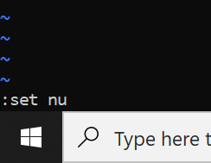

1. Make the search case insensitive

Ans-:set ignorecase

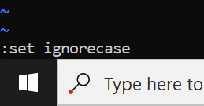

1. Delete 4 lines (and then paste them somewhere else)

Ans- 4dd and p

1. What is the command to delete part of the line starting from the current cursor position?

Press Esc come to command mode

press v enter visual mode

Shift + g "selects everything from current position to EOF"

DEL "delete selected"

1. What is the command to delete the current word?

Ans:-dw